GREAT SNAKES
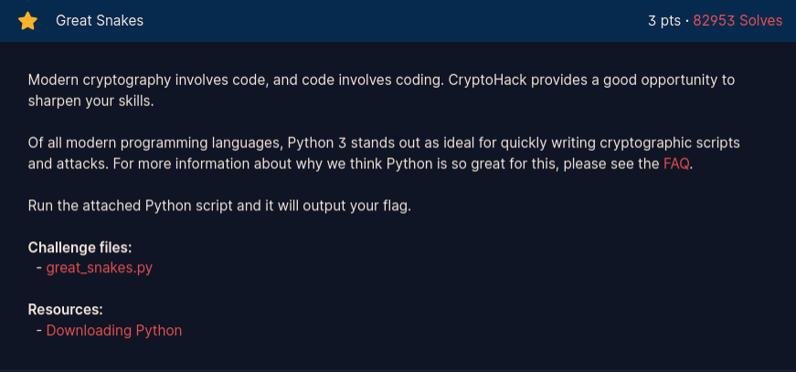
Inside the file:
#!/usr/bin/env python3

import sys
# import this

if sys.version_info.major == 2:
print("You are running Python 2, which is no longer supported. Please update to Python 3.")

ords = [81, 64, 75, 66, 70, 93, 73, 72, 1, 92, 109, 2, 84, 109, 66, 75, 70, 90, 2, 92, 79]

print("Here is your flag:")
print("".join(chr(o ^ 0x32) for o in ords))

Just simply run it:
Python3 [FILE_NAME]

Ans: crypto{z3n_0f_pyth0n}

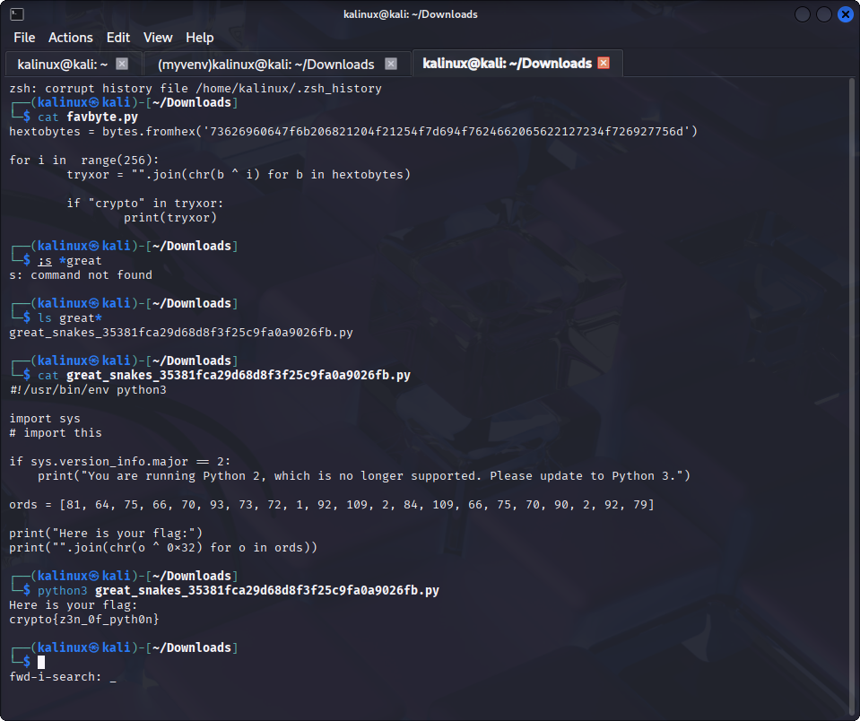

ASCII
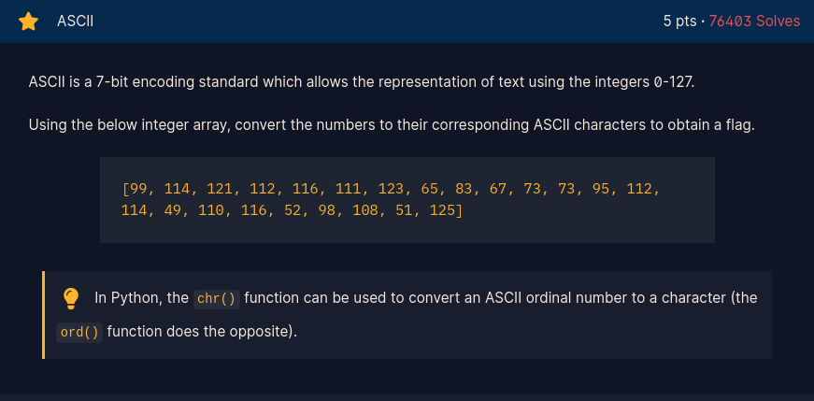

They give us some ascii in the form of a list, that means we can't just simply put the function to the list. Instead, we need to put a loop as well so it can give the proper output.

This is wrong:
print(chr(99, 114, 121, 112, 116, 111, 123, 65, 83, 67, 73, 73, 95, 112, 114, 49, 110, 116, 52, 98, 108, 51, 125))
This will work:
print(“”.join(chr(i) for i in 99, 114, 121, 112, 116, 111, 123, 65, 83, 67, 73, 73, 95, 112, 114, 49, 110, 116, 52, 98, 108, 51, 125]))

If you want to use a one-line command:
python3 -c "print(''.join(chr(i) for i in [99, 114, 121, 112, 116, 111, 123, 65, 83, 67, 73, 73, 95, 112, 114, 49, 110, 116, 52, 98, 108, 51, 125]))"

Ans: crypto{ASCII_pr1nt4bl3}

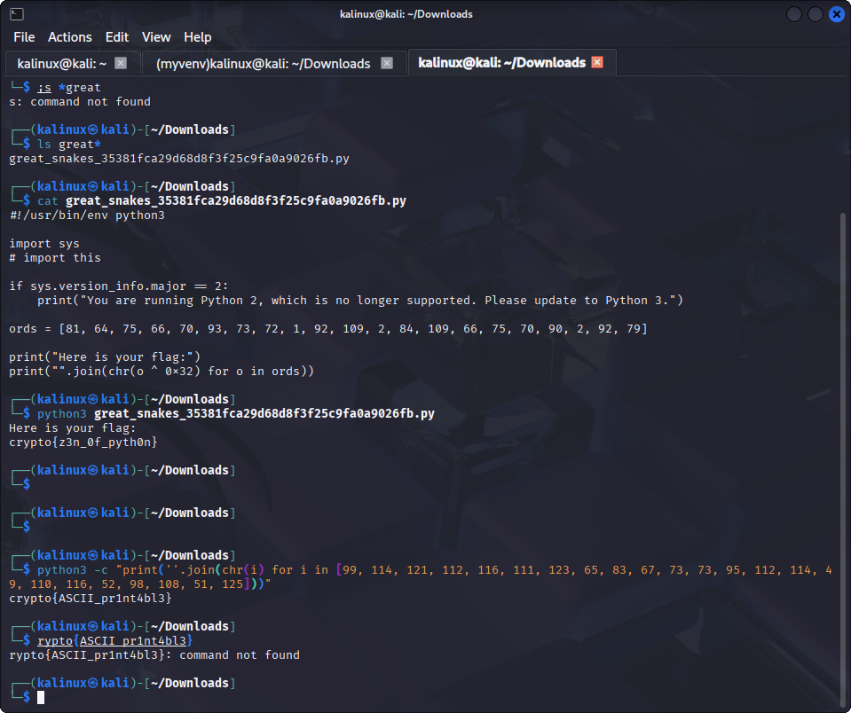

HEX
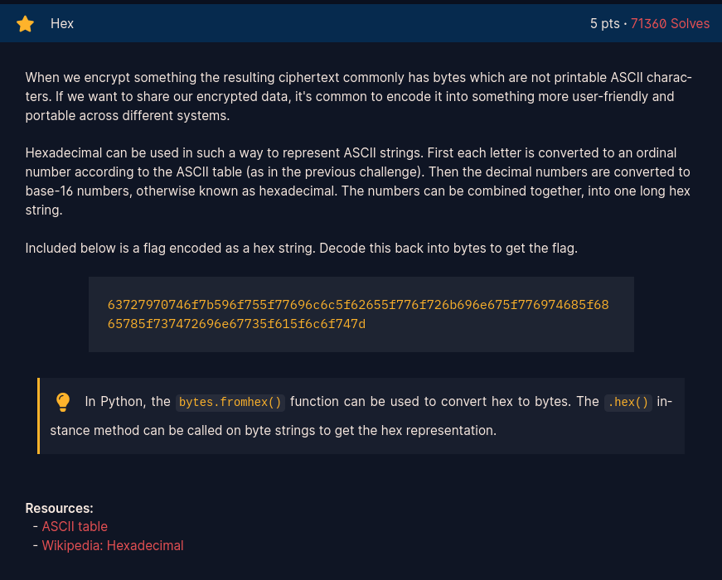

python3 -c "print(bytes.fromhex('63727970746f7b596f755f77696c6c5f62655f776f726b696e675f776974685f6865785f737472696e67735f615f6c6f747d'))"
Output: b'crypto{You_will_be_working_with_hex_strings_a_lot}'

If we test it in reverse:
python3 -c "print('crypto{You_will_be_working_with_hex_strings_a_lot}'.encode().hex())"
Output: 63727970746f7b596f755f77696c6c5f62655f776f726b696e675f776974685f6865785f737472696e67735f615f6c6f747d

Great! The codes are working properly.

Ans: crypto{You_will_be_working_with_hex_strings_a_lot}

BASE64
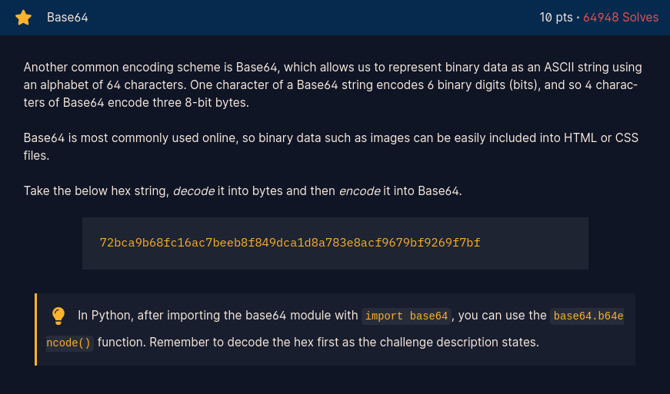

python3 -c "import base64; print(base64.b64encode(bytes.fromhex('72bca9b68fc16ac7beeb8f849dca1d8a783e8acf9679bf9269f7bf')).decode())"
Output:
crypto/Base+64+Encoding+is+Web+Safe/

Why do we need to put the bytes.fromhex() function as well here? Because the base64 function only accepts the value in bytes format, whereas they give us a hex format (we need to convert it first).

Meanwhile, the .decode() helps us to make the base64 conversion human-readable.

Ans: crypto/Base+64+Encoding+is+Web+Safe/

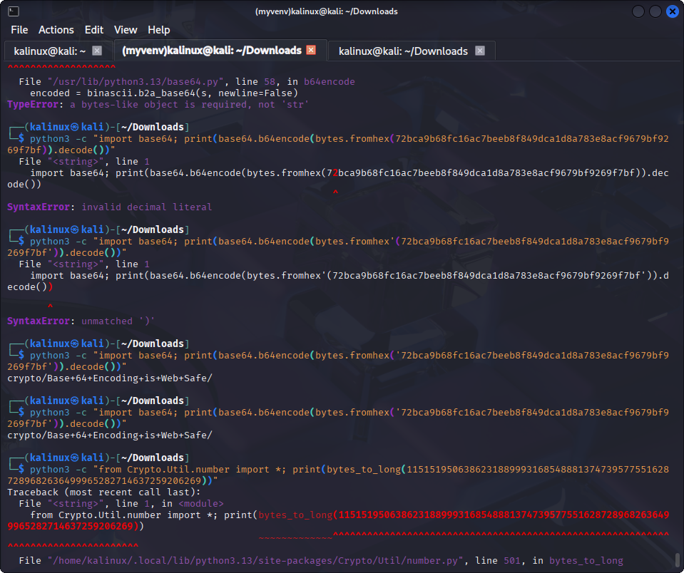

BYTES AND BIG INTEGERS
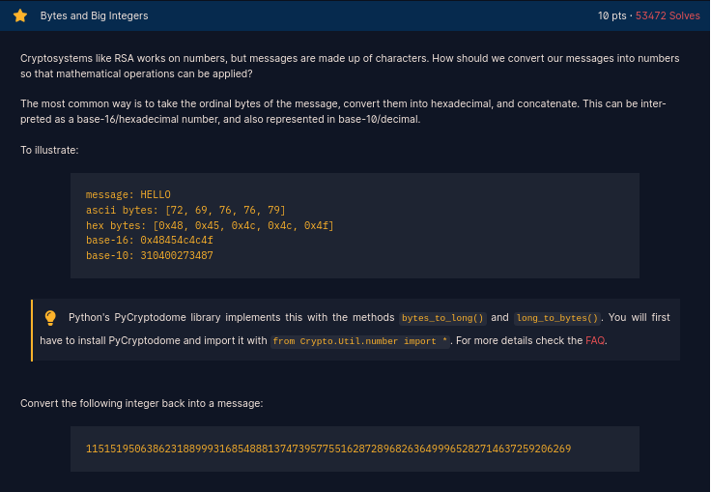

python3 -c "from Crypto.Util.number import *; print(long_to_bytes(11515195063862318899931685488813747395775516287289682636499965282714637259206269))"
Output:
b'crypto{3nc0d1n6_4ll_7h3_w4y_d0wn}'

long_to_bytes = big int > text
Ex:
from Crypto.Util.number import long_to_bytes
print(long_to_bytes(4276547)) # Output: b'ABC'
bytes_to_long = text > big int
Ex:
from Crypto.Util.number import bytes_to_long
print(bytes_to_long(b'ABC')) # Output: 4276547 (Because 'A' is 65, 'B' is 66, 'C' is 67)

Ans: crypto{3nc0d1n6_4ll_7h3_w4y_d0wn}

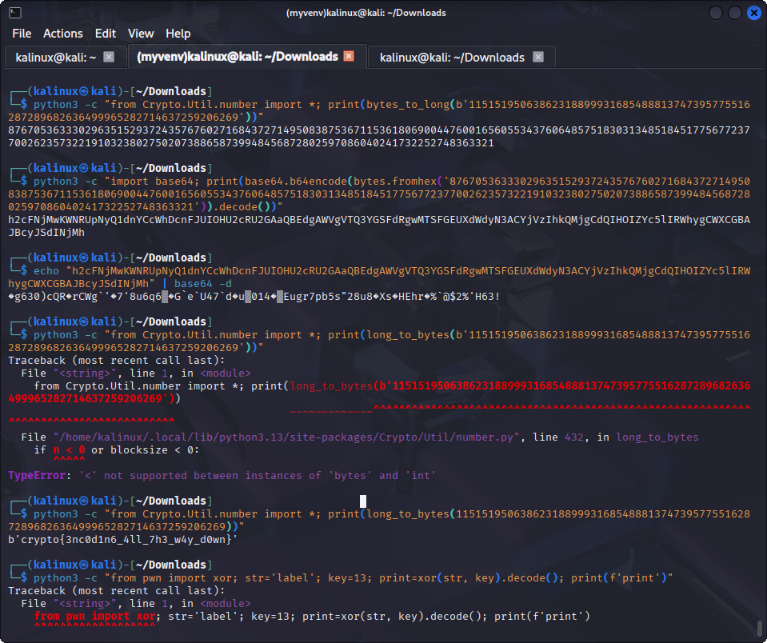

XOR
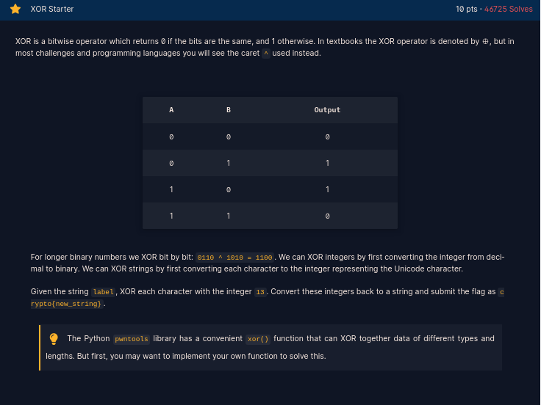

They give the key already and we know the flag format, let’s put it into python codes:

python3 -c "original='label'; key=13; result=''.join(chr(ord(c) ^ key) for c in original); print(f'crypto{{{result}}}')"
Output:
crypto{aloha}

Ans: crypto{aloha}

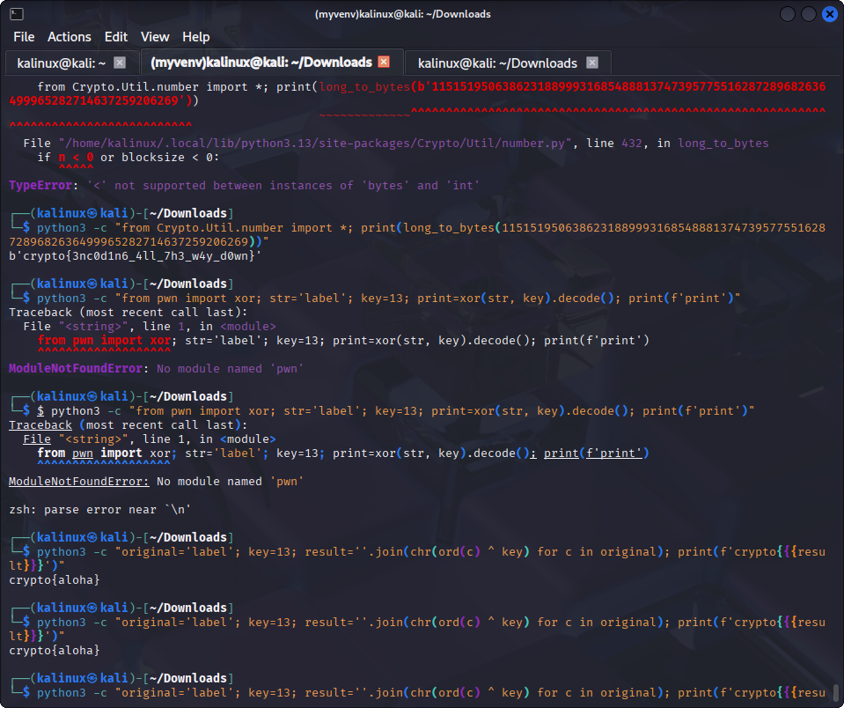

XOR PROPERTIES
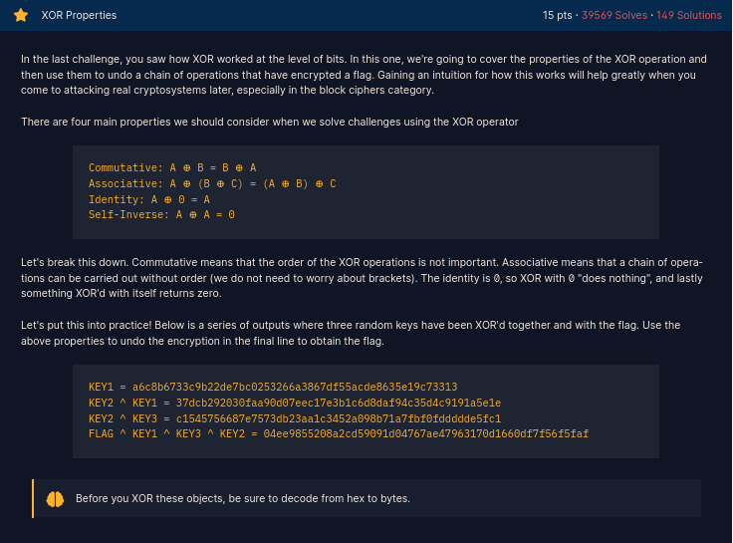

Think Xor as a light switch. If we press it once, the lamp turns on (1), and when we press it again (the 2nd time) it turns off (0).

Since the flag is xored with key1, key2, and key3, so we need to “turns off” those keys in order to get the clean flag string.

Let’s take it like this:
Line 1 = KEY1 = a6c8b6733c9b22de7bc0253266a3867df55acde8635e19c73313
Line 2 = KEY2 ^ KEY1 = 37dcb292030faa90d07eec17e3b1c6d8daf94c35d4c9191a5e1e
Line 3 = KEY2 ^ KEY3 = c1545756687e7573db23aa1c3452a098b71a7fbf0fddddde5fc1
Line 4 = FLAG ^ KEY1 ^ KEY3 ^ KEY2 = 04ee9855208a2cd59091d04767ae47963170d1660df7f56f5faf

Now we know that the light (in this case the KEYs) will “turn off” if we click the switch 2 times, so we need to make Key1, Key2, and Key3 meet each other.

(FLAG⊕KEY1⊕KEY2⊕KEY3)⊕(KEY1⊕KEY2⊕KEY3)=FLAG
*There are two KEY1, two KEY2, and TWO key3.

KEY1 ^ KEY1 = 0
KEY2 ^ KEY2 = 0
KEY3 ^ KEY3 = 0
In the end FLAG is the only left.

We’re using Line 1, Line 3, and Line 4 for the codes. Why not use Line 2? For efficiency, Since we have made the keys meet by using the Line 1, 3, and 4 already.

Let’s create the code:

from pwn import xor

k1 = bytes.fromhex('a6c8b6733c9b22de7bc0253266a3867df55acde8635e19c73313')
k2 = bytes.fromhex('c1545756687e7573db23aa1c3452a098b71a7fbf0fddddde5fc1')
k3 = bytes.fromhex('04ee9855208a2cd59091d04767ae47963170d1660df7f56f5faf ')

flag = xor(k3, k1, k2).decode()

print(flag)

Save it to .py file and run it.

Ans: crypto{x0r_i5_ass0c1at1v3}

FAVORITE BYTES
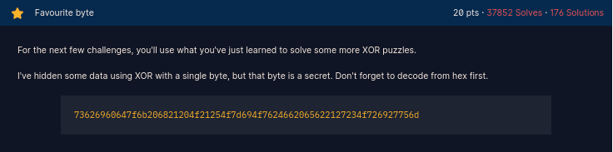

So, we are given a long hex string and it is also xored. The key of the xor is a single byte, we can just put a loop operation to guess it.

Let’s create the code:

hextobytes = bytes.fromhex('73626960647f6b206821204f21254f7d694f7624662065622127234f726927756d')

for i in range(256):
tryxor = "".join(chr(b ^ i) for b in hextobytes)

if "crypto" in tryxor:
print(tryxor)

Save it to .py file and run it.

Ans: crypto{0x10_15_my_f4v0ur173_by7e}

You either know, XOR you don't
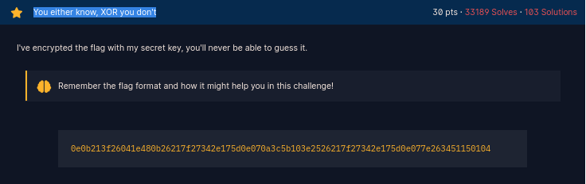

This is basically the same as the previous page challenge, but they don’t give us the key. We need to guess it and we can do that by comparing the flag format with the first 14 hex of the given hexadecimal.

Why the first 14? Because the flag format have 7 characters ‘crypto{‘ and each character is represented in a byte (2 hex).

First let’s look for the key by running this py code:
hex = bytes.fromhex('0e0b213f26041e')
format = b"crypto{"

key = "".join(chr(a ^ b) for a, b in zip(hex, format))
print(key)

Output: myXORkey

Then crack the XOR:
from pwn import xor

hex = bytes.fromhex('0e0b213f26041e480b26217f27342e175d0e070a3c5b103e2526217f27342e175d0e077e263451150104')

key = b"myXORkey"

print(xor(hex, key))

Ans: crypto{1f_y0u_Kn0w_En0uGH_y0u_Kn0w_1t_4ll}'

>>>>>>>>>>>>>>>>>>>>>>>>>>>>>>>>>>>>>>>>>>>>>>>>>>>>>>>>>>>>>>>>>>>>>>>>

Tentu, ini adalah ringkasan singkat kompetensi yang sudah kamu pelajari dari walkthrough CryptoHack tersebut:

1. Fondasi Data (Encoding)
- ASCII/Ords: Mengubah karakter teks menjadi angka (integer) dan sebaliknya.
- Hexadecimal: Membaca dan memproses data mentah dalam basis 16 (bytes.fromhex).
- Base64: Mengonversi data biner menjadi teks yang aman untuk dikirim lewat web.
- Big Integers: Mengubah angka yang sangat besar menjadi teks (long_to_bytes) untuk keperluan RSA.

2. Operasi Logika (XOR)
- Mekanisme Dasar: Memahami bahwa A⊕B⊕B=A (XOR dua kali dengan kunci yang sama akan mengembalikan data asli).
- Sifat Aljabar: Memahami bahwa urutan XOR tidak berpengaruh (associative & commutative).
- Brute Force: Teknik mencoba semua kemungkinan kunci (0-255) jika kunci hanya 1 byte.
- Known Plaintext Attack: Menebak kunci dengan cara melakukan XOR antara data terenkripsi dengan format yang sudah diketahui (seperti crypto{).

3. Pemrograman Python untuk Kriptografi
- Manipulasi Bytes: Penggunaan .encode(), .decode(), dan bytes.fromhex().
- Efficiency: Menggunakan List Comprehension dan join() untuk memproses data dalam satu baris.
- Library Kripto: Menggunakan Crypto.Util.number dan pwn (pwntools) untuk operasi tingkat tinggi.

